File Organiser

### How to

The file organiser renames files adding a sequential numbering to each based on name and filetype.

If you have a bunch of files with random numbering and want them organised then this will do it.

Firstly, files must already be named in the following way:  
<name>_<seq_num>.<extension>

e.g. awesome_01.jpg   
awesome_27.jpg

A file extension may not show in all systems or all settings. So if you only see “awesome_01” then in most cases you should be fine, or if you see a mix of some having it and some not, the program will error if it cannot figure it out.

To get a copy of the program first navigate to [filepathhere]/fileorganiser

You will see the following:

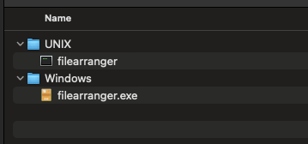

Pick the version for your system, UNIX for Linux or macOS machines and Windows for Windows machines.

Put it somewhere you will remember. Once done, simply double click on it and you will be greated by the following:

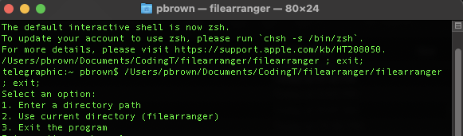

Option 1 will then prompt you for the directory path to where the files are.

Option 2 will run the program in the directory you have the fileorganiser program in.

Option 3 will exit the program.

When using the option 1 you will need to provide the full path.

EG  
Windows: F:/myfolder/theimages

UNIX: /Users/pbrown/Documents/theimages

Option 2 will just run whereever the program is sitting, so instead of putting the program in a random spot you can just put it in the folder you have your images and run it form there.

Option 3 will quit the program.

When the program runs it will iterate over all the files in the folder or path it was sent too. It will find all files matching the input requirements explained above and rename them, sequencing them based on filename + filetype. All files that do not match the naming expectations will not be touched.

The program then will output all files it modified.

In the below screenshot we can see a example. On the far left is the images in “raw” unorganised formatting, to the right after being cleaned up and on the far right the output from the program showing what files were changed.

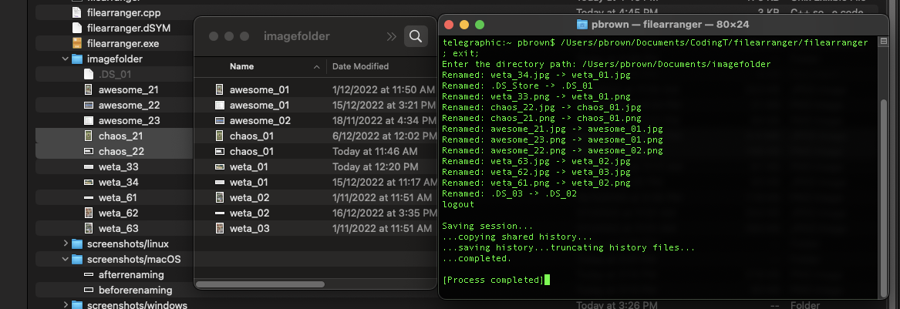

The program provides the options so that you the user can pick whichever option best suits you at the time. If using it is a one off thing never to be done, then placing it in the folder with the files to be renamed is probably the best. But if you think or expect to use this on a regular basis then putting the program somewhere else and giving the filepath will be best.